 | 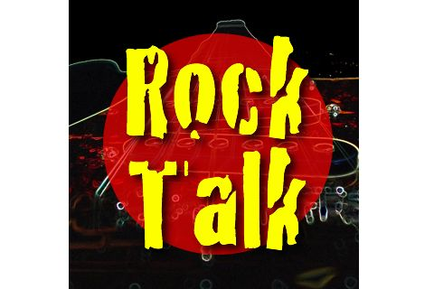
Host (irritated): I’m sorry folks, but my producer Dave has just informed me that our scheduled guests missed their flight following their concert last night and we’ve had to make some last minute changes. So...
(sound of papers rustling)
Host: Ok. So tonight on Rock Talk on the phone we have one the most influential groups in history....

the Dead Liberal Philosophers!
 | 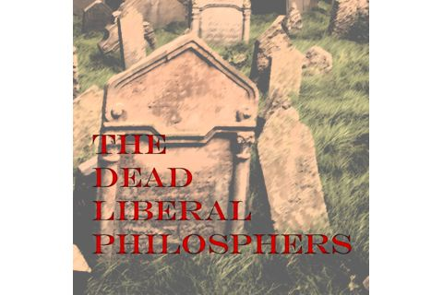
Host (whispered): Influential groups? I’ve never even heard of this band, Dave. You can’t expect... Ok. ok. Just follow the script, I get it.
Host: So on the phone here I have the Dead Liberal philosophers. That’s uh, John Locke
 | 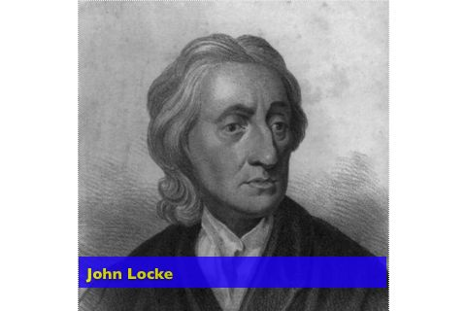
Locke: That is correct?
Host: Baron Montesquieu | 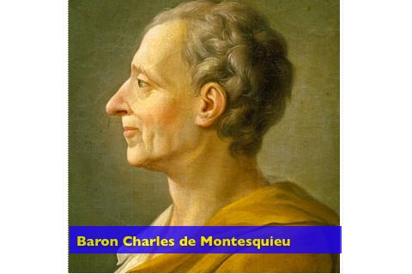
Montesquieu: Oui!
Host: ...and John Stuart Mill | 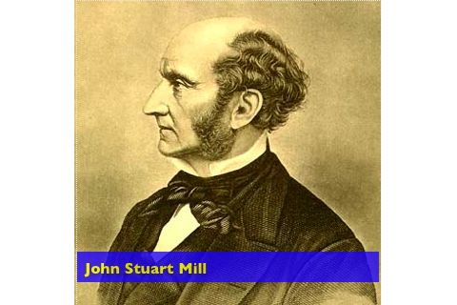
Mill: Hello
Host: Well, welcome to Rocktalk and thank you for agreeing to do this interview on such short notice. It says here you guys have been in the business for a long time. So who’s the oldest member of the group.
Locke: Well, I’ve been dead for 300 years, so I guess that makes me the oldest. | 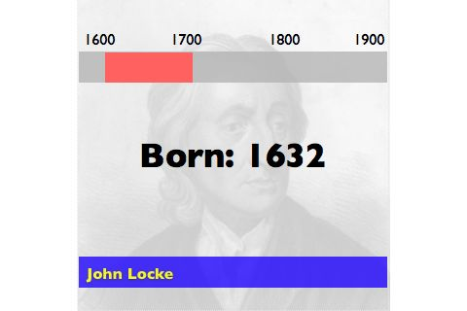
 | 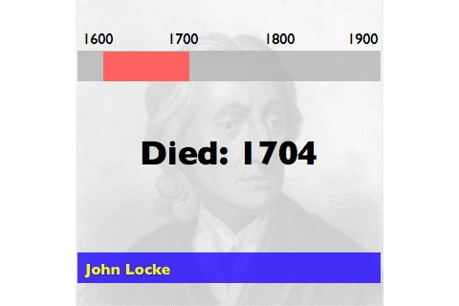
Host: You’re a funny guy John. Dead for 300 years. What about you Montie? How long have you be a “Dead philospher”. | 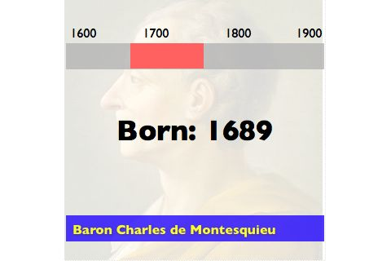
Montesquieu: I have been dead for around 250 years and you may call me Baron Montesquieu or “Charles” | 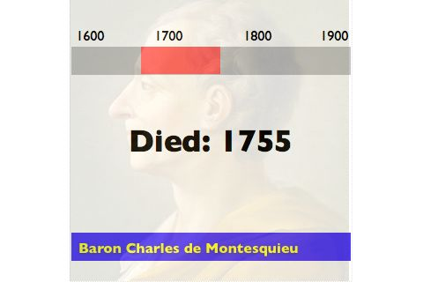
Host: Rock stars. Such prima donnas. Ok Baron. “ Baron” it is.
John Stuart Mill, look for the sake of our listeners, can I just call you J.S. Otherwise we’ll be talking about two Johns here.
Mill: J.S. will suffice.
Host: How long have you been dead then. | 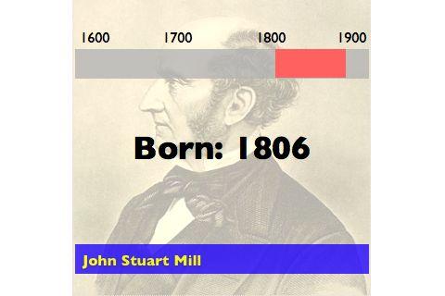
Mill: A little over 125 years | 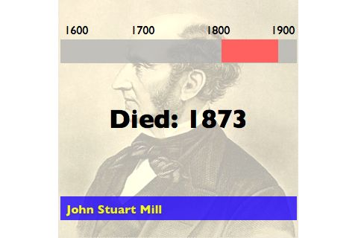
Host: I guess that makes you the youngest in the group. You guys crack me up. We’ll get Dave to do a little research during the break and we’ll see if we can get some real facts on these guys.
Well, I’m looking at the backgrounder Dave gave me and it looks like you all had pretty impressive solo careers before joining the band. John Locke, it says your first album was entitled Two Treatises of Government. Bit of a strange name for an album. Still, it looks like to you had a lot of hits. Tell me a little bit about this song tabula rasa. | 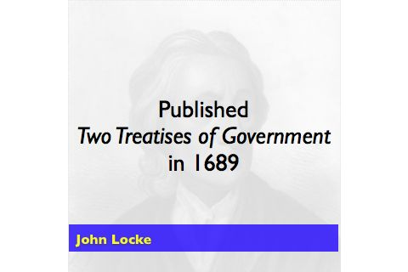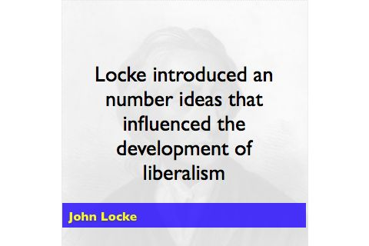  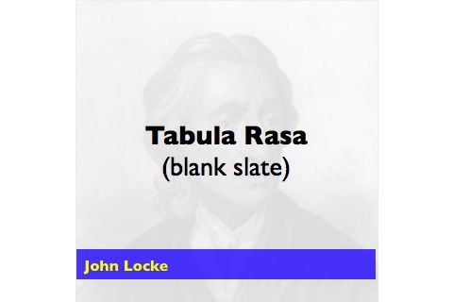
Locke: Well, er its not a song, young man, it’s and idea about the nature of human beings.
Host: Oh, I see. This must have been part of a concept album.
Locke: Well,... er,... anyway, tabula rasa is Latin for blank slate. My belief is that human beings are born with their personalities unformed. We are empty, unwritten on, if you will. We become good or evil based on our experiences as we grow. | 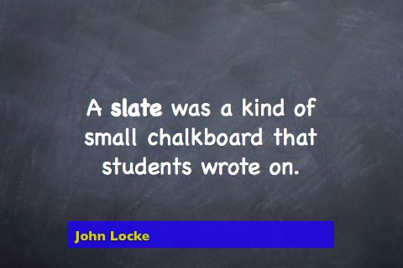
 | 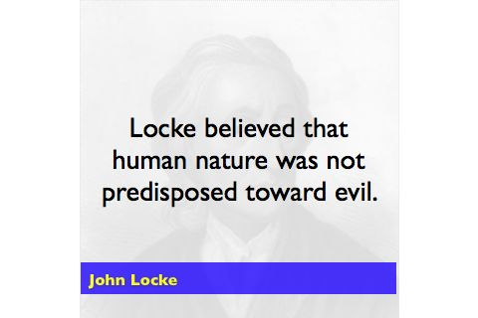
Host: Wow, so it’s not like that song Bad to the Bone, you know where the nurse can tell right away that the kid is going to grow up bad. | 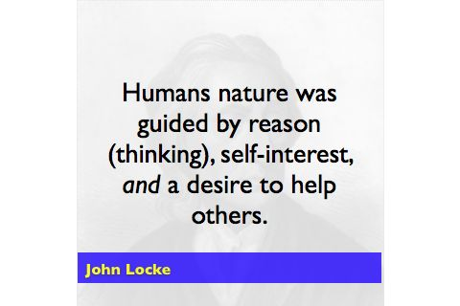
Locke: Oh, no no. That would be something like my contemporary Thomas Hobbes might have written. He believed that people were basically selfish and were it not for the strong hand of strong and absolute ruler, society would descent in to murder and chaos. It’s a rather bleak view of humanity. | 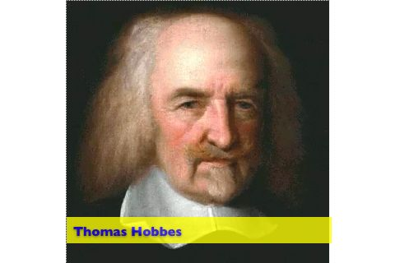  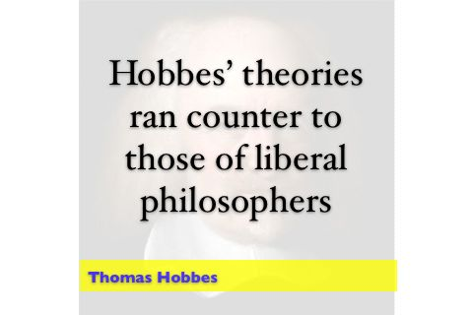
 | 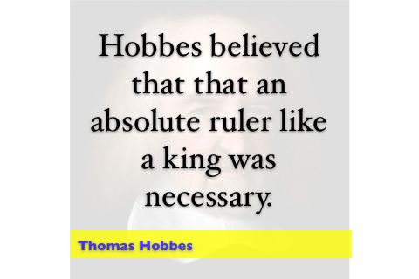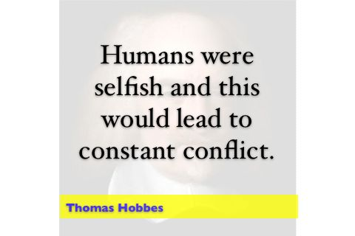
Host: Yeah, it does sound kind of dark. This Hobbes guy must have been into Death Metal. | 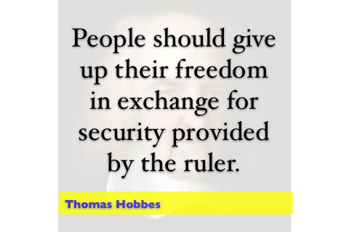
Locke: Yes, well he did say that life without a strong ruler would be “nasty, brutish and short”. | 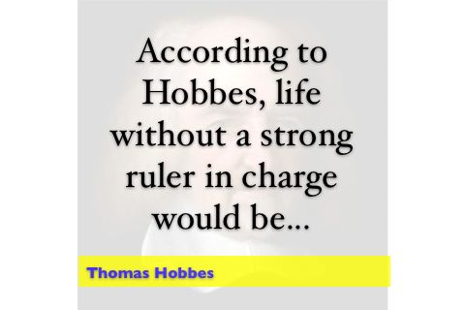  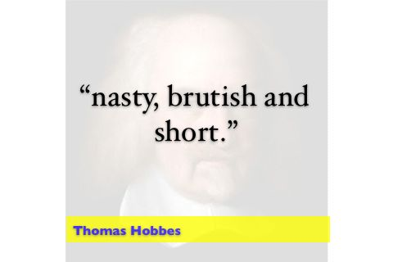
Host: Ok. Well, in case you just joined us, we’re talking to John Locke, one of the original members of the group, the Dead Liberal Philosophers. So John, what can to tell me about one of your biggest hits, Social Contract. | 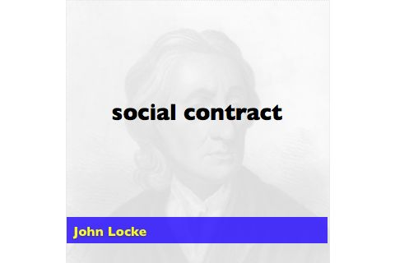
Locke: The Social Contract, as I see it, is an agreement between the government and the people they govern. You see everyone is born with what we call, natural rights... the right to life, liberty and property. However, people may sometimes disagree on the interpretations of these rights. For example, two business people might get into a dispute over some property, feeling that they both have a right to it. Without rules and laws to help them sort out their differences, they might resort to violence. Someone might even be killed! The role of government, then, is to write laws and enforce laws that help people get along with each other. By doing this they fulfill their role of protecting the right to life, liberty and property. | 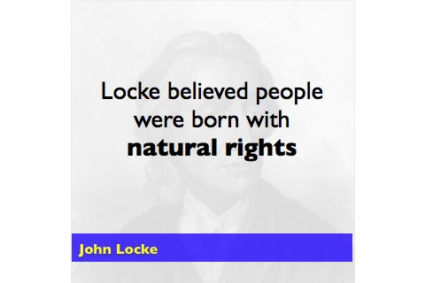  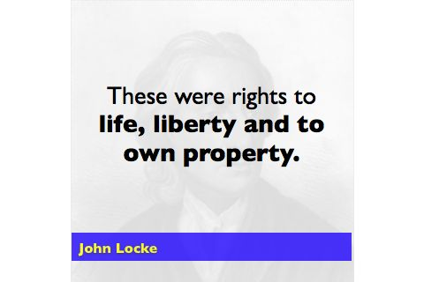  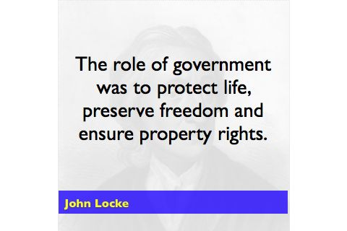
Host: I don’t know John. I’ve never trusted the government very much. Really, what’s to stop them from just coming in and taking everybody’s property.
Locke: Where that’s where this is a contract, you see. People agree to abide by the laws set out by the government. However, if the government or it’s laws undermine the people’s right to life, liberty and property, well the government has violated its contract with the people. In such a case the people would be well justified in rising up and overthrowing the government. | 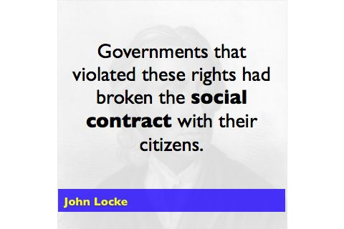  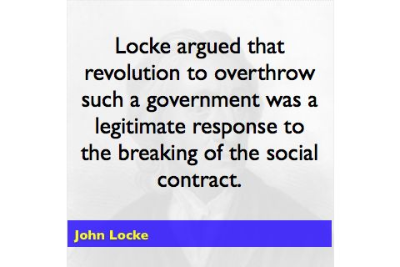
Host: Ok. I..I see. So it’s sort of a power to the people kind of thing. Social contract must have been a big hit during the 60s. | 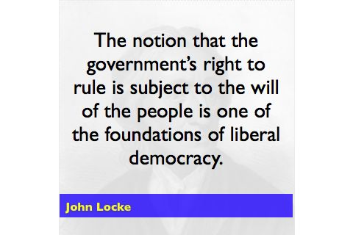
Locke: Yes, that’s right actually, I really seemed start making an impression on people in the 1760s.
Host: (a little stunned and confused by Locke’s response): The 1760s....(lengthy pause)
Well...Uh... ok.
Uh, Great.
Well, I’ve been talking to John Locke, one of the founding members of the Dead Liberal Philosophers. It’s time for us to go to commercial. When Rock Talk comes back we’re going to talk to the Dead Liberal Philosphers’ French connection, Baron Charles Montesquieu.
COMMERCIAL
END COMMERCIAL
Jingle music and host’s voiceover: You’re listening to Rock Talk. And now, back to our show.
Host (whispered): Come on, Dave. You have to admit, they’re kind of weird. I mean the Locke guy really thinks he’s been dead for 300 years. He must have been crowd surfing at a concert and someone dropped him on his head. Oh, oh... we’re on.
Host: OK. Welcome back to Rock talk. We’re lucky to have the Dead Liberal Philosophers on the phone with us tonight. Now Baron Montesquieu, judging from this song title, Separation of Powers, I’m guessing your career was heavily influenced by the hair metal.
Montesquieu: Ahh. no. Actually, my concept of the separation of powers was somewhat influenced by Jean here. Ee wrote about it in is works but you know I took de idea and develop it furder. The idea of separation of powers is dat no one person or group should ave all de power in government. The power should be separated and given to three different branches of the government, a legistative branch to make the laws, a executive branch dat would put the laws into effect and enforce dem and a judicial branch that would decide if a law had been broken and punish the lawbreakers. | 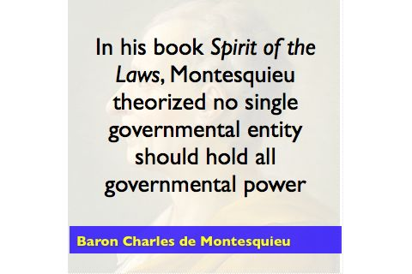  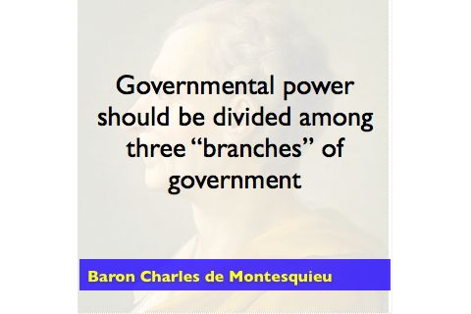  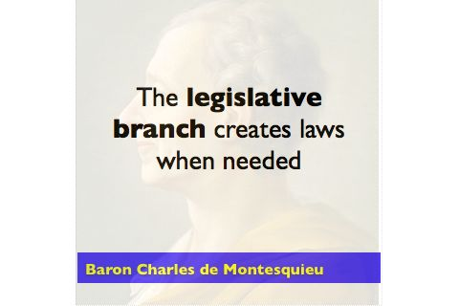  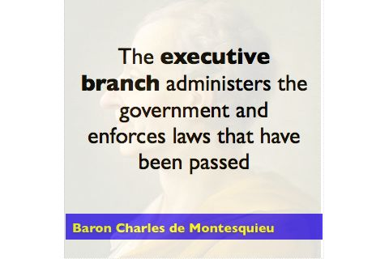  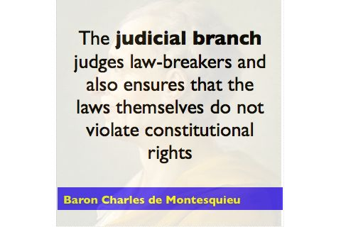
Host: Ok, Baron, I have to be honest with you. I’ve never actually heard it, but sounds like the lyrics to Separation of Powers would have been well, uh, pretty dry. You can’t really tell me that this was a big hit for you?
Montesquieu: Indeed it is was. The idea was very influential. In fact it is popular in many countries even today. | 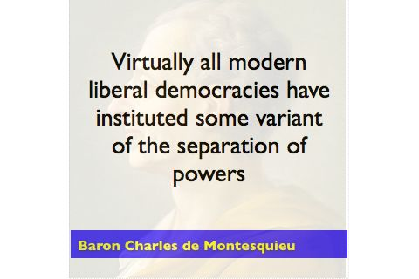
Host: Ok guys, Dave want’s me just to take a minute to apologize to our listeners for the poor quality of our telephone connection tonight. On my end, you guys sound like your talking on another planet. I’m sure the audio can’t be too good for our audience. We’d like to thank you all for your patience. Dave’s got our technician Terry looking into the problem.
In the meantime, I’d like to take a couple moments to talk to John Stuart Mill.
So J.S., you joined the band later than John and the Baron. According to the sheet Dave gave me, you’ve often been credited with bringing a fresh perspective to the band.
Locke: (chuckling): Yes, we like to say J.S. put the “i” in liberalism. | 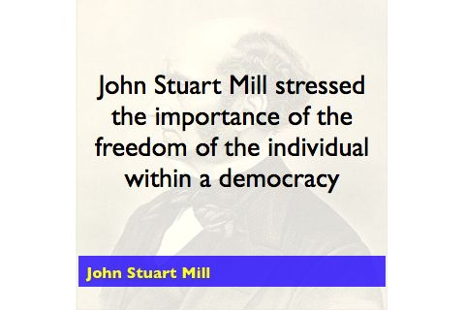
Mill: Well, I suppose to a certain extent that’s true. | 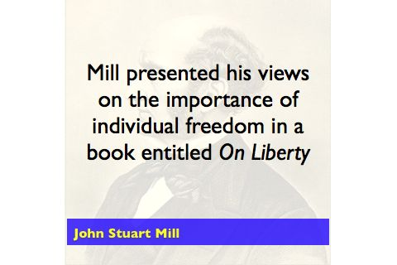
Host: Uh, I’m not quite sure what you guys are talking about.
Mill: Well, when I came on the scene, you know, a democratic tradition had already been established, at least in Britain. My concern was that rule by the majority could be rather, well, unpleasant, if you were part of the minority. | 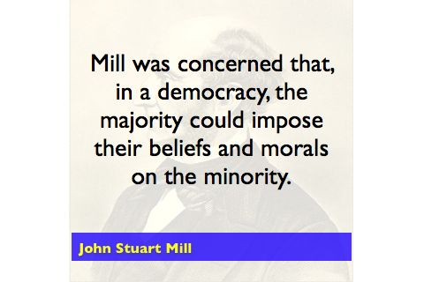
Host: Ok, but I’m still not quite seeing what this has to do with the band. You had this big hit called On Liberty. Were these concerns what spurred you to write On Liberty.
Mill: I suppose they were. In On Liberty, I argued strongly that the rights of the individual should have supremacy the will of the majority.
Host: I’m not following you...
Mill: Well, take for example that rather shabby looking shirt you’ve got on or that gold jewelry that you’ve had impaled in your tongue.
Host: Yeah, what about them? He wait how to do you know what I’m wearin...
Mill (interrupting): Well, what if the majority of people felt that your appearance was somehow inappropriate? Some interpretations of democracy would hold that if the majority of the people voted for a law against shabby shirts or the skewering of one’s own tongue, you could be jailed for looking the way you do. | 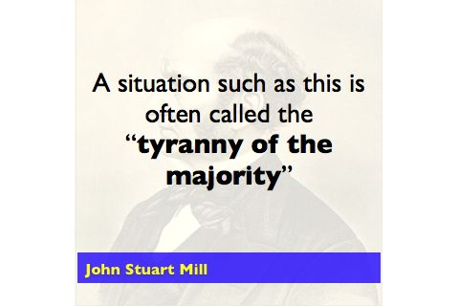
Host: (a bit confused and becoming a bit indignant): Hey this is my most comfortable t-shirt and.. well... it’s my tongue. If I want to stick sharp things through it that’s my own business!
Mill: That was precisely the point I was making in On Liberty. The individual should be allowed to do pretty much whatever they please, provided that their actions do not hurt others. We philosophers call that “the harm principle”. | 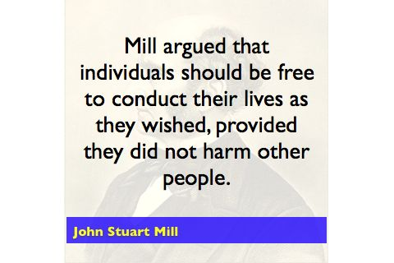
Host: Cool. Sounds like an endorsement of the typical rock star lifestyle. But, you know when you think of it, there were a lot of rock stars who died as a result of doing whatever they wanted. You know, drug overdoses and such. What if everyone acted that way?
Mill: But most people don’t act that way. For example, I know many dead musicians and most of them would argue that a broader interpretation of individual liberty allowed them the push boundaries and give society new musical forms, like your rock and roll. Only a tiny minority expressed their individual liberty in self-destructive ways. This is true of the wider population as well. The freedom to act as an individual is, on the whole, is positive for society. Society as a whole benefits from achievements of individuals. | 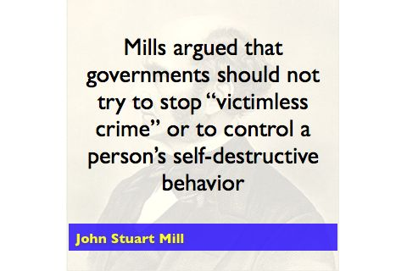
Host: Wow, pretty deep stuff, J.S. In fact, a lot of your guys’ material is well, pretty heavy. Did you ever write a love song? I mean, you know back in the day, you guys must have had female fans.
Montesquieu: (laughing): Oh not so much Jean and I, but J.S. ear, wuz big wit the ladies. | 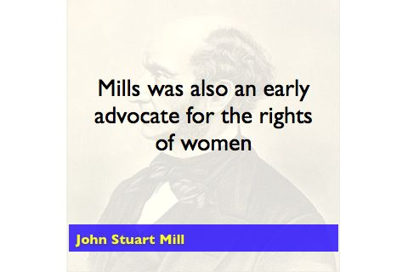
Locke: Yes, well it wasn’t his sparkling eyes. In some of his later writings, J.S. brought forth the idea that women should be equal to men. It was quite a radical proposal for the time.
Host: O.K., we’re talking to the Dead Liberal Philosophers. We’ll be back to wrap up our chat with the band after this commercial break.
COMMERCIAL
Narrator: He’s been called the father of capitalism. The most influential economist in the history. And now, available for the first time, the musical adaptation of Adam Smith timeless work, The Wealth of Nations. | 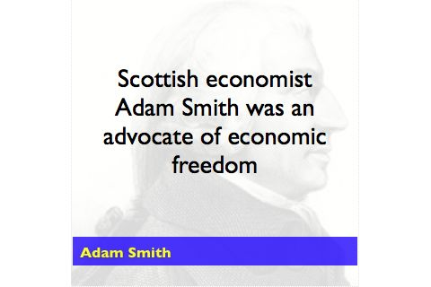  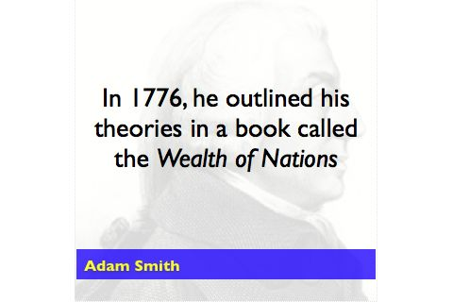
You’ll hear all of Adam Smith’s best ideas become his best songs. (these are to be sung with a Scottish accent)
There are stirring rock ballads like Invisible Hand
I’m a seller  So I try to sell high  But you’re the consumer  And you want a low price if you’re gonna to buy  We’ll haggle and on a fair price we’ll agree  That’s the invisible hand that guides the economy | 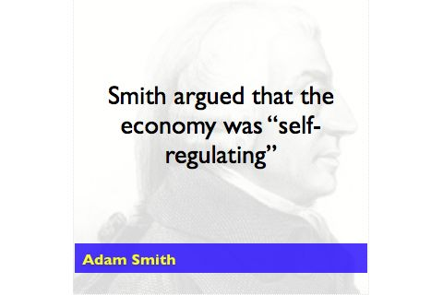  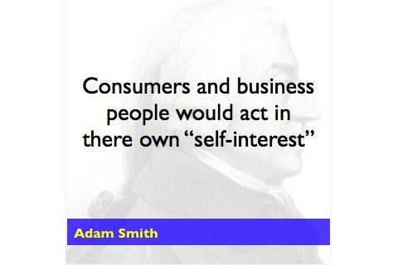  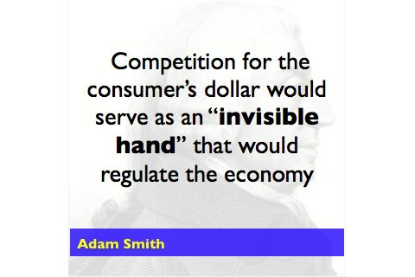
Narrator: Or Smith’s capitalist anthem Laissez Faire
We don’t need no government  to tell us what to sell  keep your hands off the economy  and it’ll run well  We want the freedom to conduct business  with anyone, anywhere  hands off!  Laissez Faire | 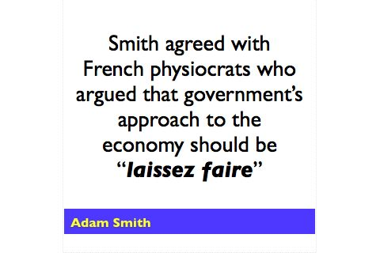  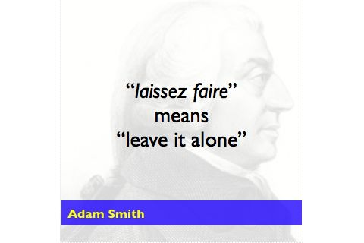
Narrator: And in a special treat, Smith covers the Enlightenment era protest song, Let the Free Market Reign
Hey you kings, you mercantilists  hoarding all your gold  trying to control all the things  that are bought and sold  there’s a new way of doing business  capitalism is it’s name  Mercantilism is a dead idea  let the free market reign | 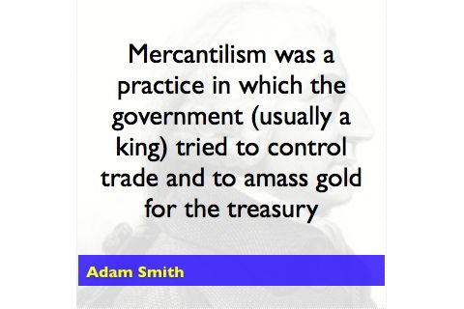\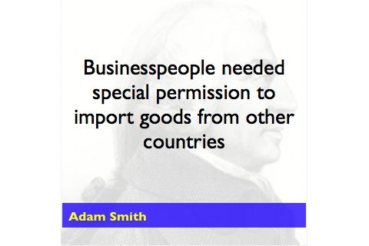  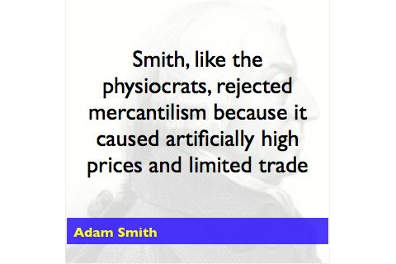
Adam Smith’s The Wealth Of Nations... on sale now
Commercial
END COMMERCIAL
Jingle music and host’s voiceover: You’re listening to Rock Talk. And now, back to our show.
Host: We’ve been talking by phone to the members of the world renowned band The Dead Liberal Philosophers. Well gentleman, our time’s almost up. I guess I have a couple more questions for you before we have to let you go.
Mill: By all means
Host: What would you say has been the biggest impact of your work? | 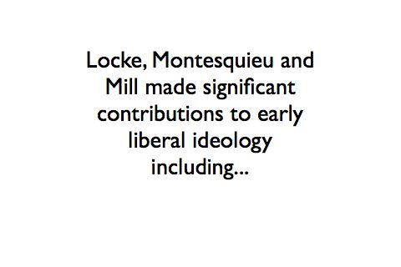
Locke: We’ll I like to think the ideas we put forth helped to shape the world’s concept of what a free and democratic society should look like. We drove home the point that the people should have the ultimate power over the government. | 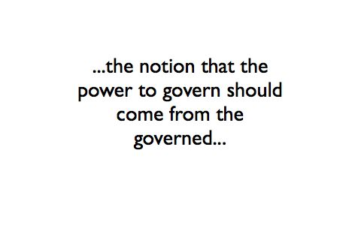
Montesquieu: Yes, and we provide ideas for how to control and limit da power of da government. | 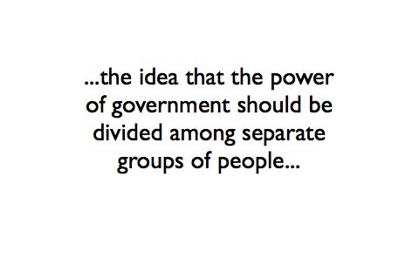
Mill: I like to think we expanded the definition of freedom beyond the simple notion of the population being free from the rule of kings. We helped introduce the concept of individual freedom...the right of all of us to be different, to manage our own lives largely as we wish without interference from the rest of society. | 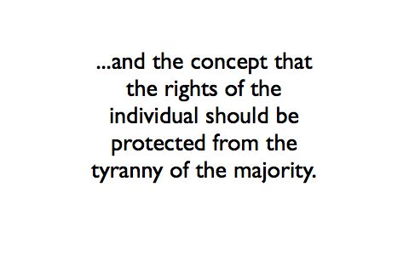
Host: Wow. Pretty heavy stuff. Do you guys have any plans for a reunion tour?
Locke: (chuckling): Well, our present state of health, I don’t think so.
Montesquieu and Mill: (laughter)
Host: One final question that’s been bugging me. J.S., when we were talking earlier, how did you know what I was wearing? I mean, you can’t see me. We’re on the phone.
(Locke, Mill, & Montesquieu all laugh (echo effect - sound fades out)
(Suddenly the line apparently goes dead...sound of dial tone.)

